COMP 0560: Artificial Intelligence I
Final Exam
Fall 1998

Chapter 1: Introduction to AI

- [10pts] In the textbook, the authors discuss 4 approaches for (in defining) Artificial Intelligence. List and briefly describe two of them?

- [10pts] What is the Turing test? List 3 areas of AI that are needed in order to allow a machine to pass this test.

- [5pts] What is the primary difference between symbolic and subsymbolic approaches to AI? Of these two approaches, which do you think is more effective? Explain your answer.

COMP 0560: Artificial Intelligence I
Final Exam
Fall 1998

Chapter 2: Agents

- [10pts] What is an ideal rational agent?

- [10pts] Explain the relationship between ideal mappings and ideal rational agents?

COMP 0560: Artificial Intelligence I
Final Exam
Fall 1998

Chapter 3: Uniformed Search

- [10pts] Give the initial state, goal test, operators, and path cost (if applicable) for the problem of finding the phone number of IHOP in Auburn, given a stack of Alabama telephone directories.

- [10pts] Using the Figure below, what order will the nodes be visited using (a) iterative deepening, (b) uniform-cost search.

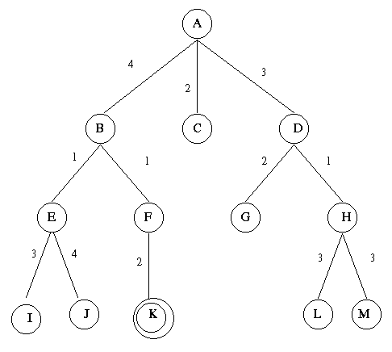

COMP 0560: Artificial Intelligence I
Final Exam
Fall 1998

Chapter 4: Informed Search

- [5pts] (True or False) All A* algorithms use heuristics that are admissible.

- [5pts] (True or False) All A* algorithms use monotone heuristics.

- [5pts] According to the textbook, what is perhaps the best way to develop an admissible heuristic?

- [5pts] What is the effective branching factor of a heuristic? How can it be used to determine if one heuristic is more informed than another?

COMP 0560: Artificial Intelligence I
Final Exam
Fall 1998

Chapter 5: Game Playing

- [10pts] Using the two-ply game tree below. Show what MAX’s best first move would be using Alpha-Beta pruning. Make sure that you identify which edges are to alpha/beta pruned.

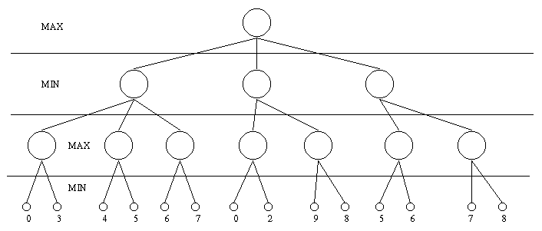

COMP 0560: Artificial Intelligence I
Final Exam
Fall 1998

- [10pts] Briefly explain how the expectiminimax algorithm works. Is it possible to apply alpha-beta pruning to game trees with chance nodes? Explain.

COMP 0560: Artificial Intelligence I
Final Exam
Fall 1998

Chapters 6,7,9: Propositional & First Order Logic

- [5pts] Explain why p(f(x,x),A) does not unify with p(f(y,f(y,A)),A).

- [10pts] Explain the difference between a denotation, an interpretation, and a model.

- [10pts] Convert the following sentences into first-order logic and use resolution refutation (along with Green’s Theorem) to find out: Who is a member of the Sierra Club who is a mountain climber but not a skier?

Jim, Dave, and Ted belong to the Sierra Club. Every member of the Sierra Club is either a skier or a mountain climber or both. No mountain climber likes rain, and all skiers like snow. Dave dislikes whatever Jim likes and likes whatever Jim dislikes. Jim likes rain and snow.

COMP 0560: Artificial Intelligence I
Final Exam
Fall 1998

Chapters 10: Logical Reasoning Systems

Answer either question 17 or 18

- [30pts] Represent the follow set of sentences as (a) sentences in first order logic (b) a semantic network, and (c) as a Prolog program.

All people who are not poor and are smart are happy. Those people who read are not stupid. Jill can read and is wealthy. Jack is also wealthy. Happy people have exciting lives.

If it was later found that Jack could read and was not a happy person, which of the above systems could most easily represent this new information. Provide an illustration.

COMP 0560: Artificial Intelligence I
Final Exam
Fall 1998

- [30pts] Develop a production system for determining the greatest of 4 numbers supplied (sequentially) by a user. Be sure to state the conflict resolution strategies that you will be using and trace through your program showing the changes to working memory.

COMP 0560: Artificial Intelligence I
Final Exam
Fall 1998

Introduction to Genetic Algorithms

- [10pts] What is a Genetic Algorithm?

- [10pts] Describe briefly how genetic and hill-climbing search can be combined to form a hybrid search technique. Would such a hybrid be useful (Explain)?

- [10pts] Given that you are trying to find a near optimal solution to a non-stationary optimization problem, what type of GA would you use: Generational or Steady-State? Explain your answer.

COMP 0560: Artificial Intelligence I
Final Exam
Fall 1998

COMP 0560: Artificial Intelligence I
Final Exam
Fall 1998

COMP 0560: Artificial Intelligence I
Final Exam
Fall 1998

